OWASP TOP 10 –HTB

1.Looking glass

Using ;ls with ip address

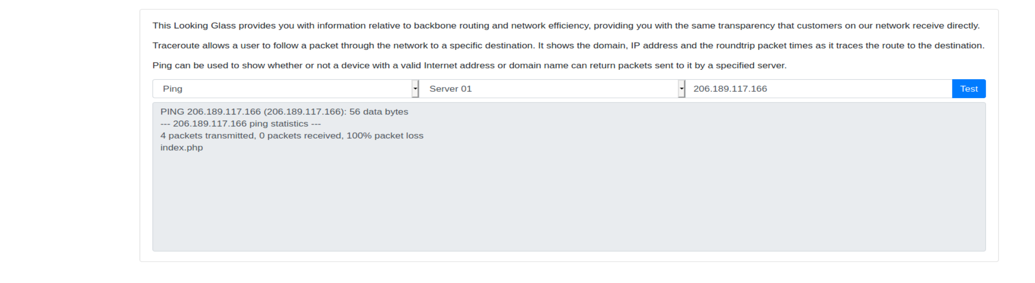

Little more command injection ;ls / for looking root directory

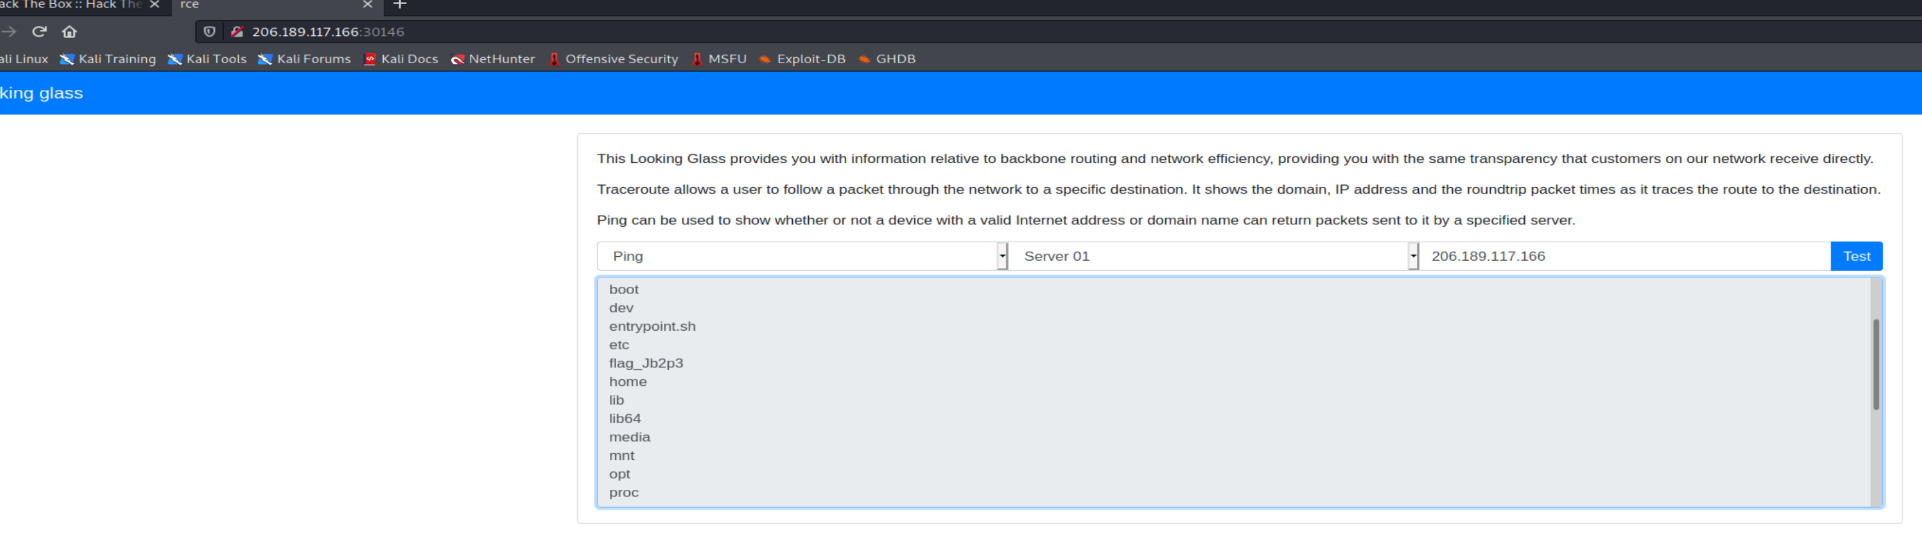

Cat /flag_name

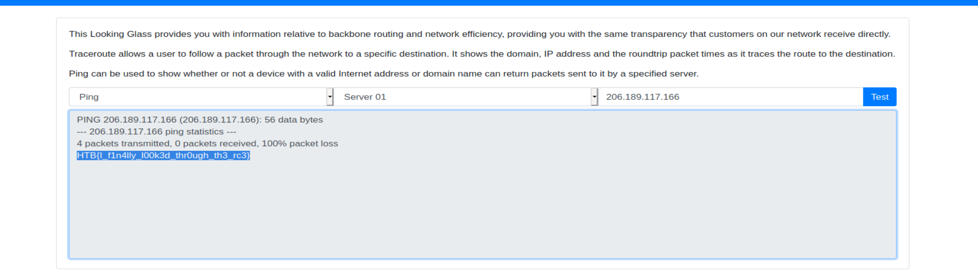

 Baby Nginxatsu

After creating a account and few config



We can see laravel after googling I found it a php framework .The config created can be check as <http://Ip_addr/config/51>

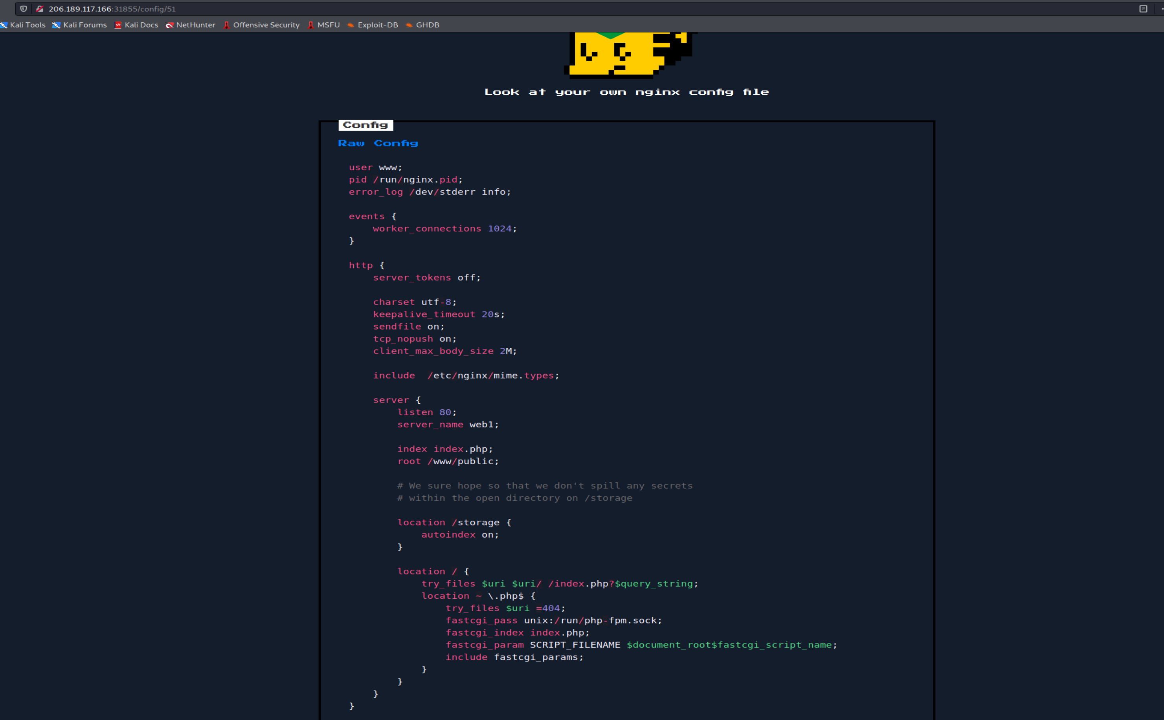

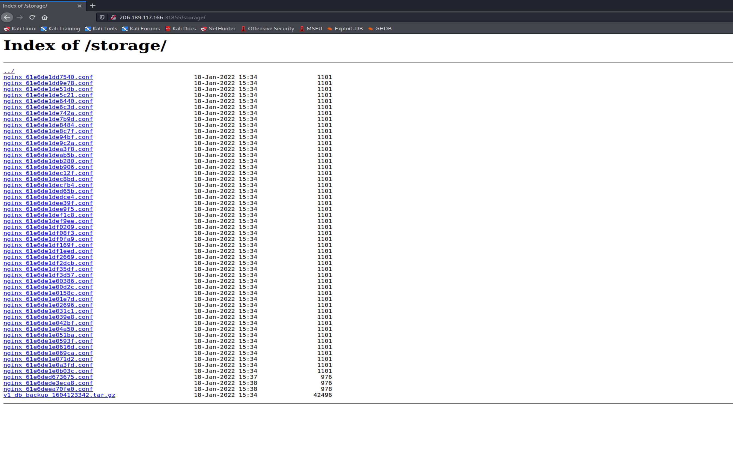

Wget the tar file shown above and load to db browser for sql

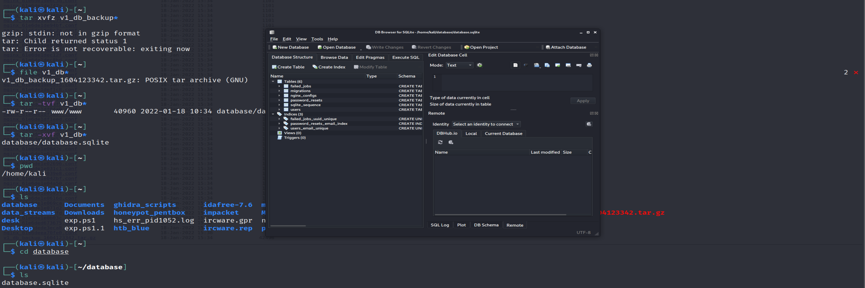

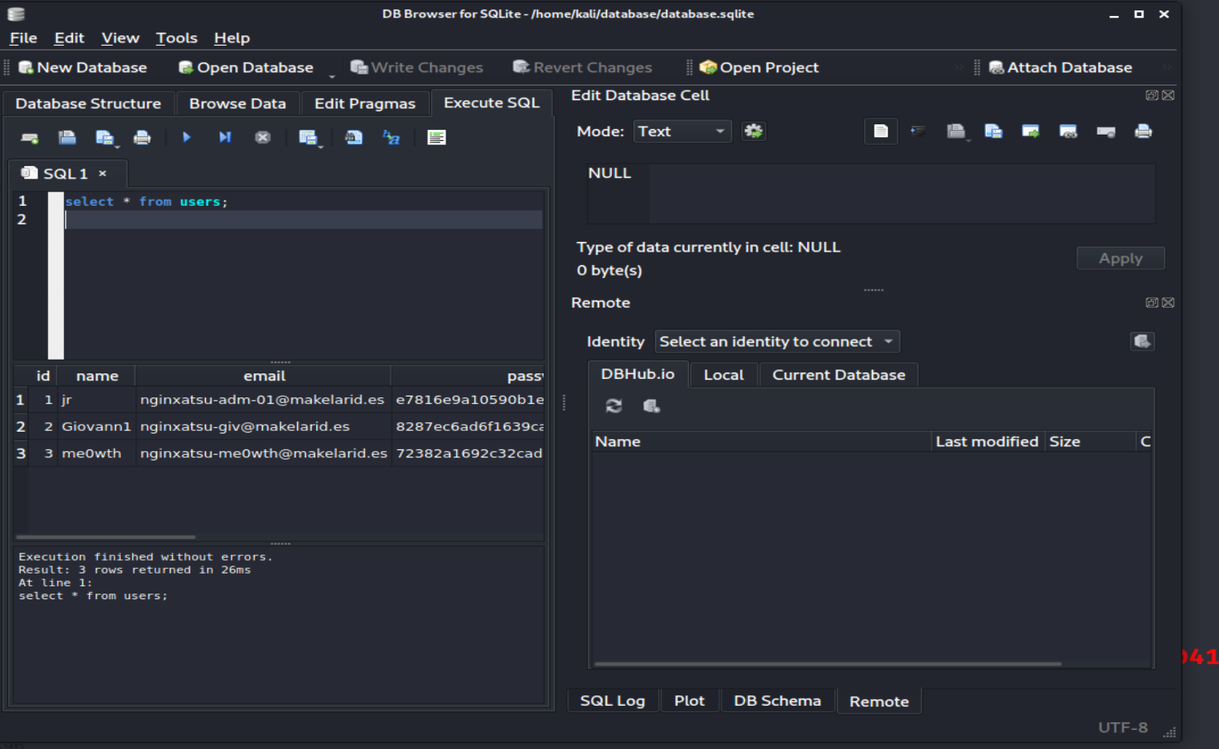

Storing the hashes with email for future reference

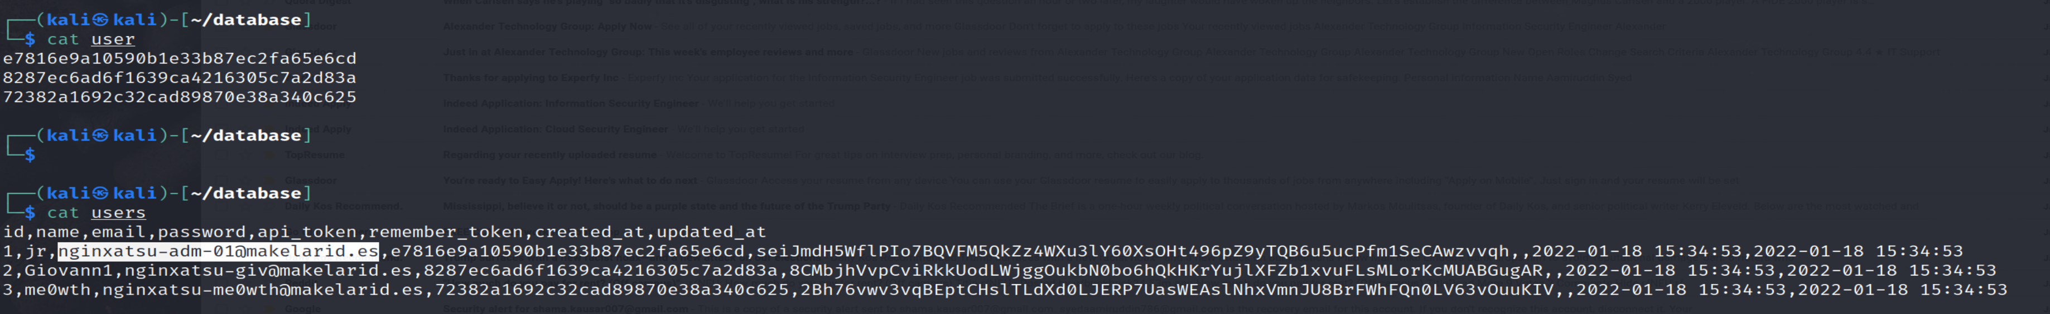

Running hashcat on the hash file

Hashcat -m 0 passwordfile /usr/share/wordlists/rockyou.txt

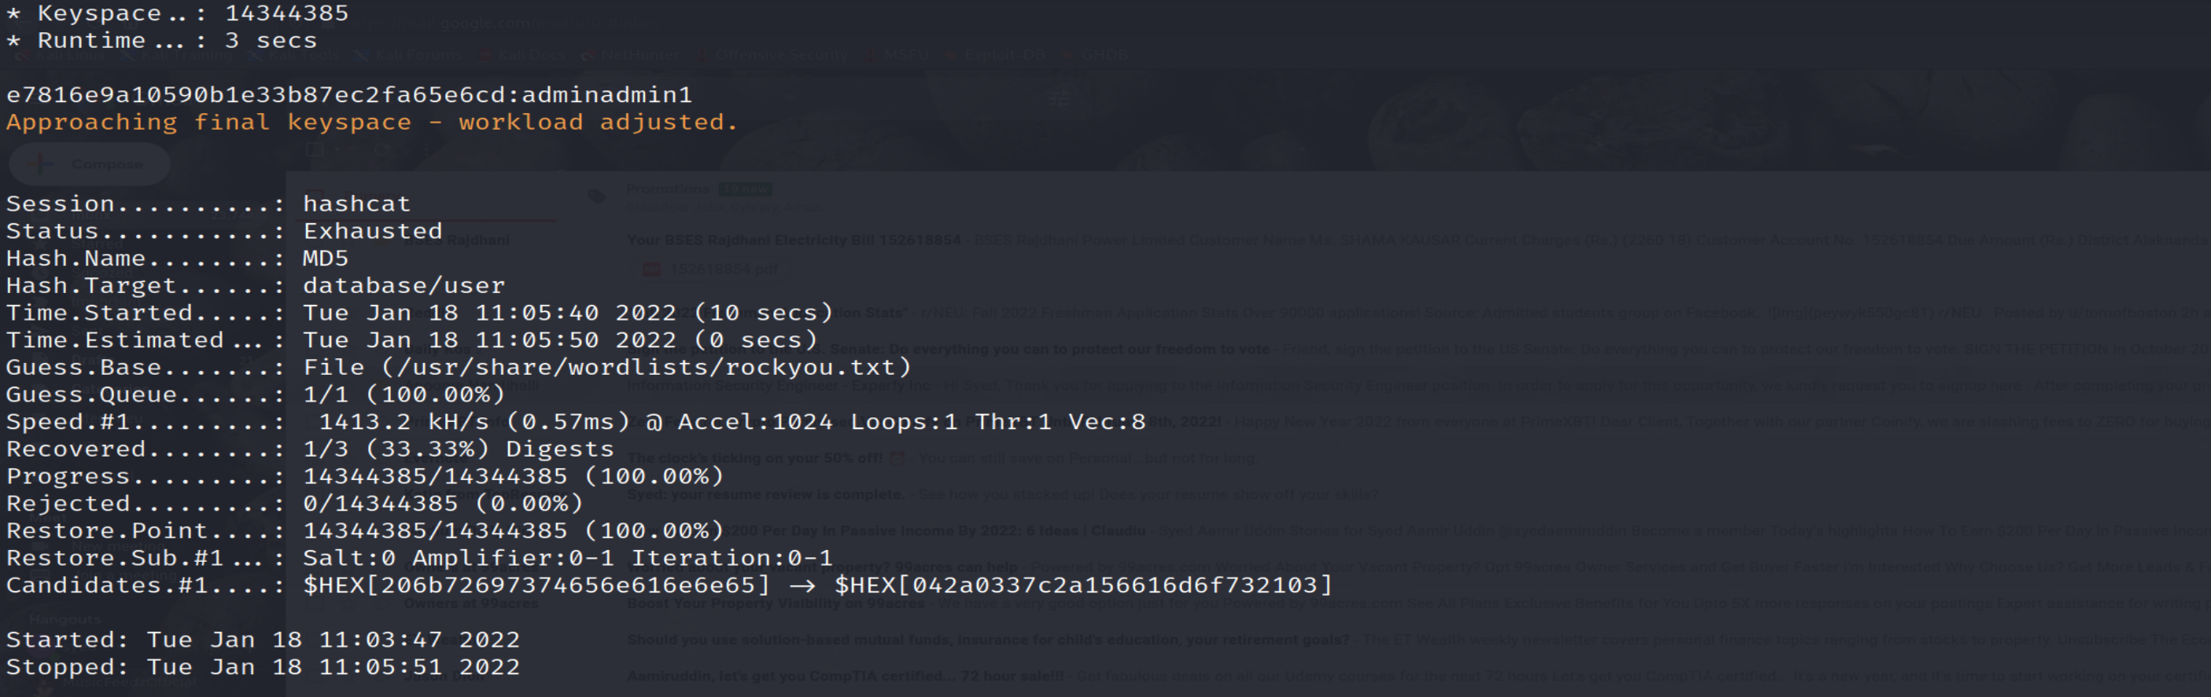

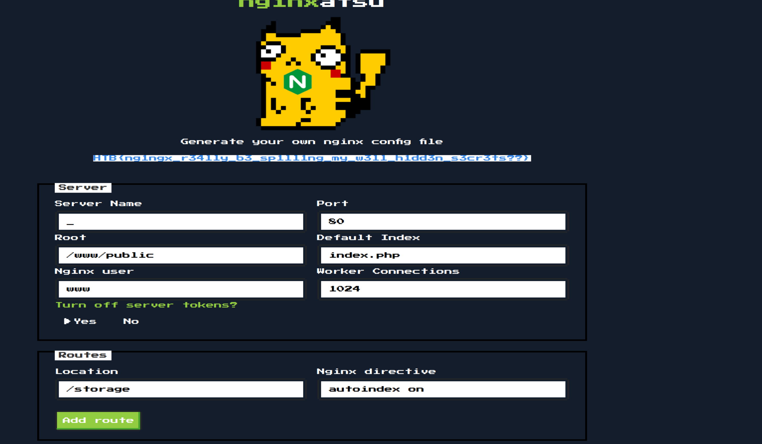

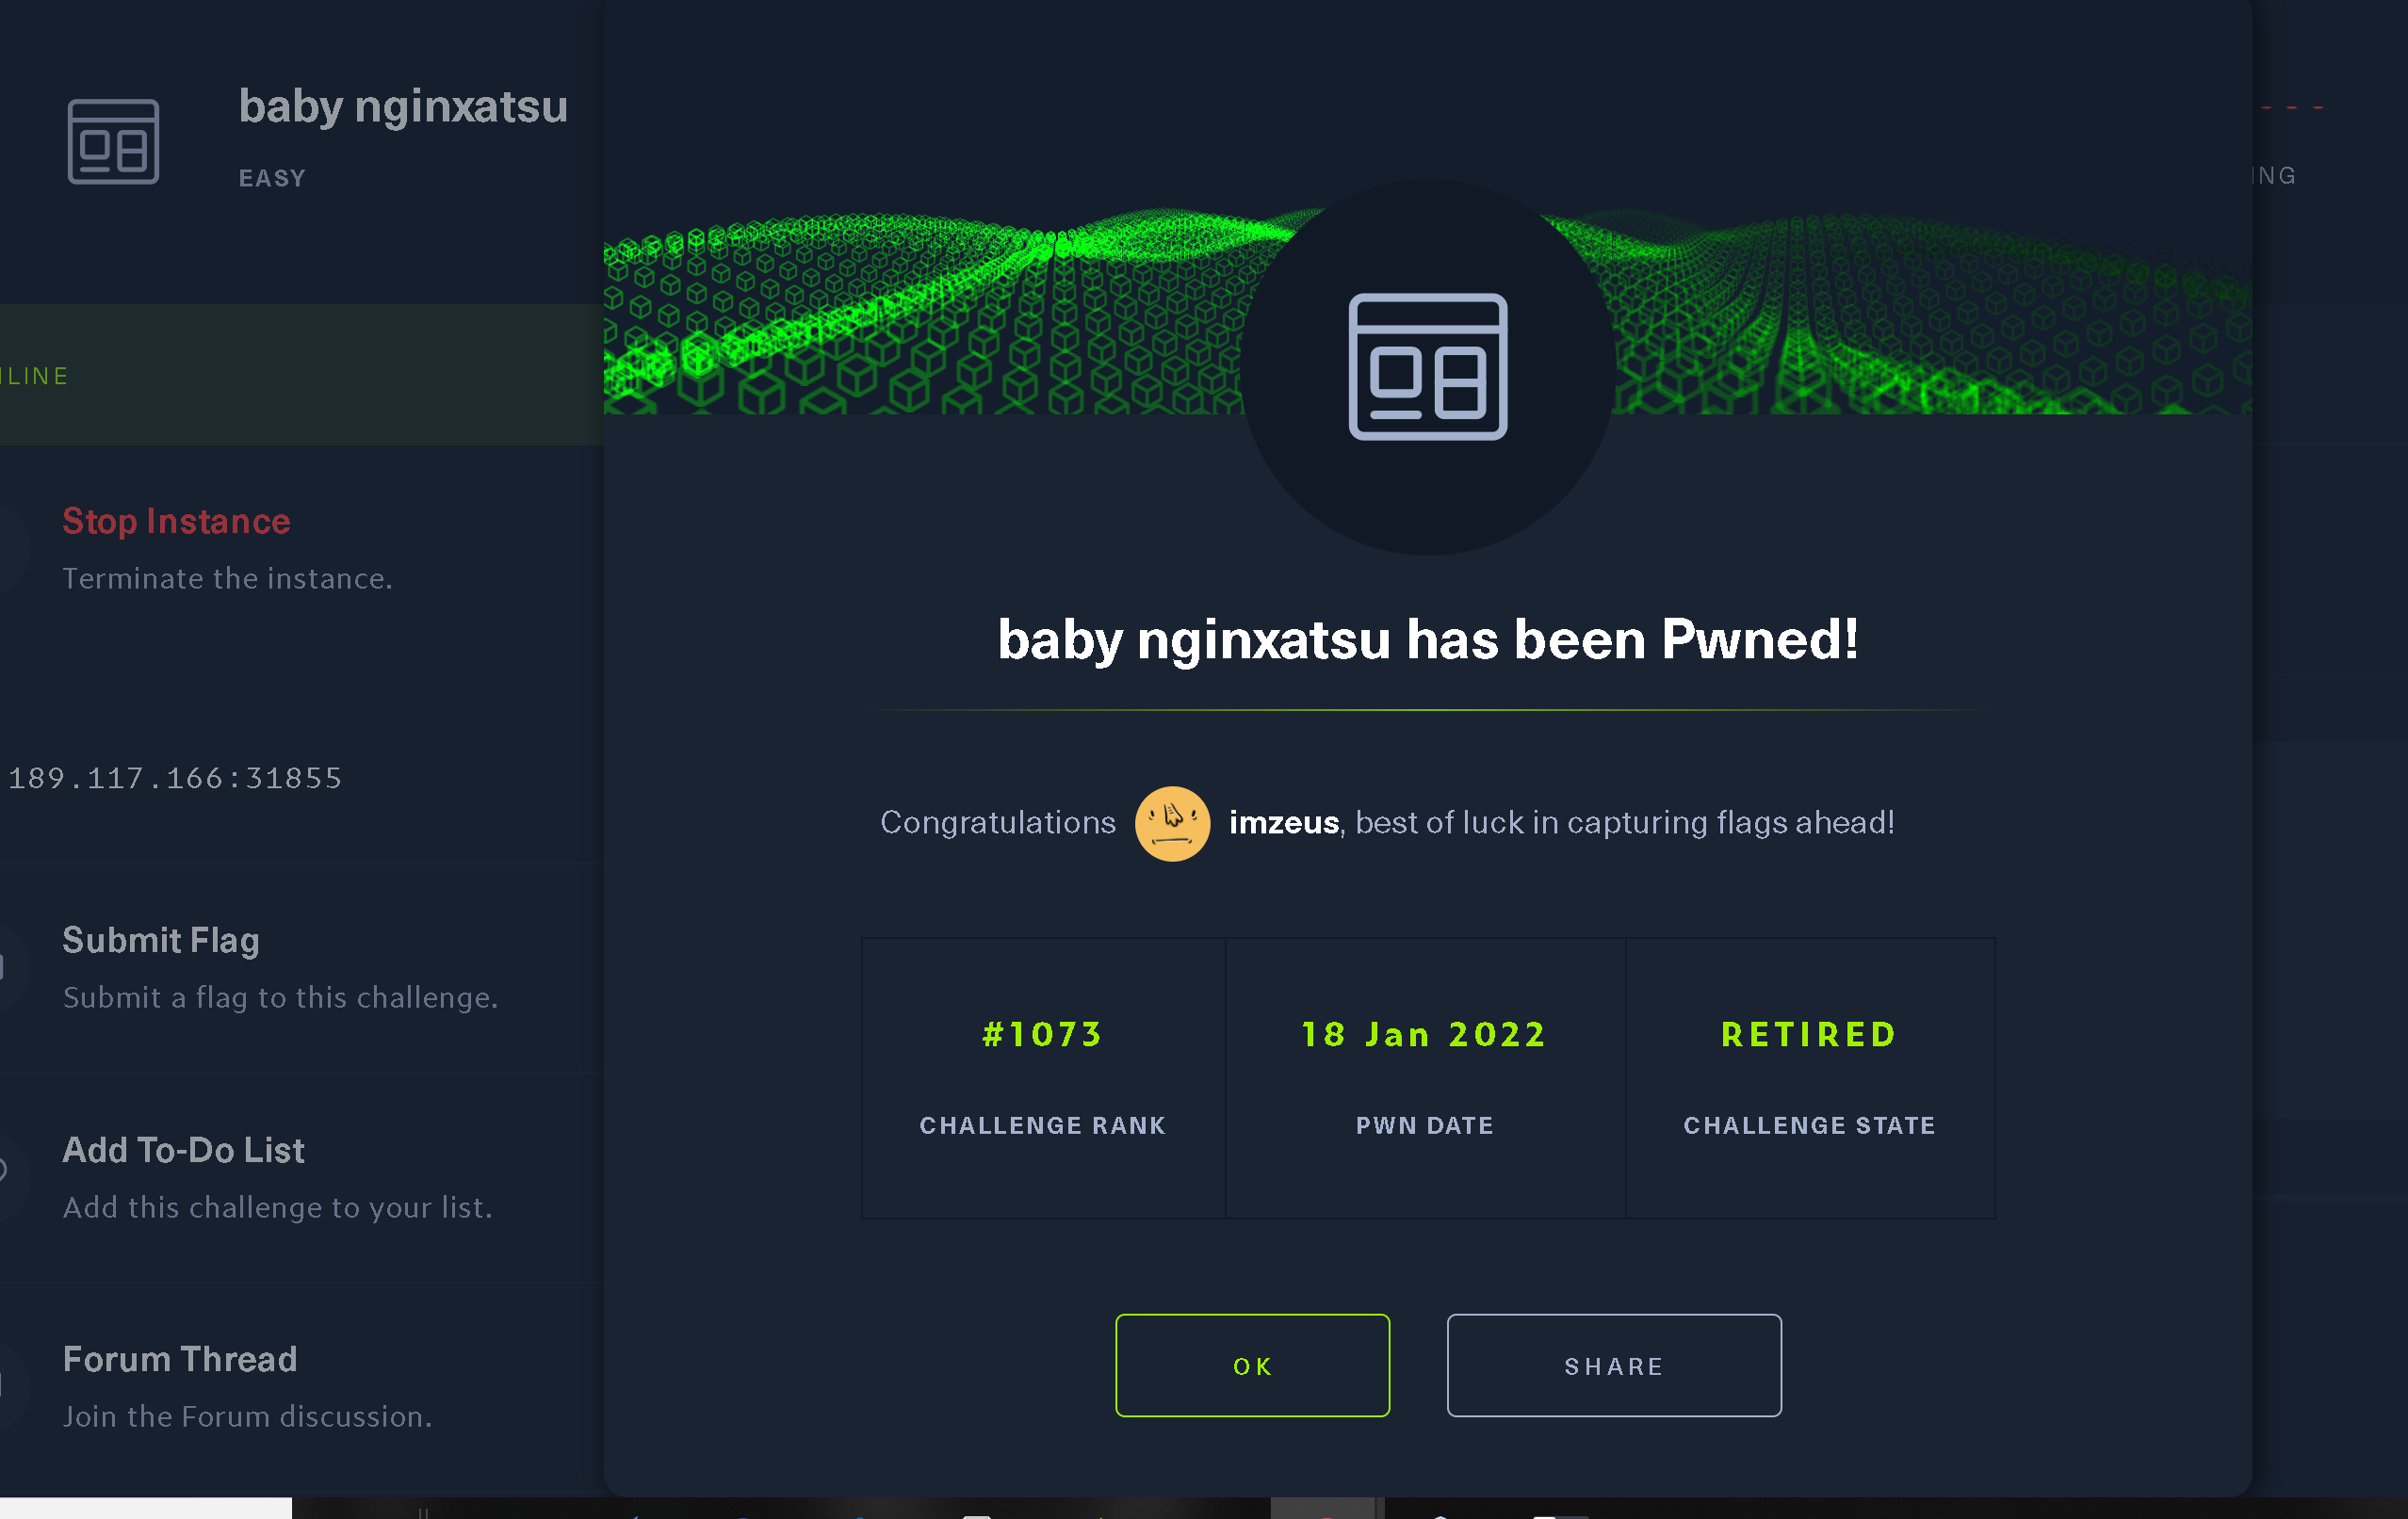

**baby WAFfles order**